ML ASSIGNMENT 4

Video link: <https://drive.google.com/file/d/1oPKUEB3YldDE0MefRDLPjkxt25Z3U7JI/view?usp=sharing>

1. Apply Linear Regression to the provided dataset using underlying steps. a. Import the given “Salary_Data.csv” b. Split the data into train test partitions, such that 1/3 of the data is reserved as a test subset. c. Train and predict the model. d. Calculate the mean squared error e. Visualize both train and test data using a scatter plot

1. Apply K means clustering in the dataset provided: • Remove any null values by the mean. • Use the elbow method to find a good number of clusters with the K-Means algorithm • Calculate the silhouette score for the above clustering

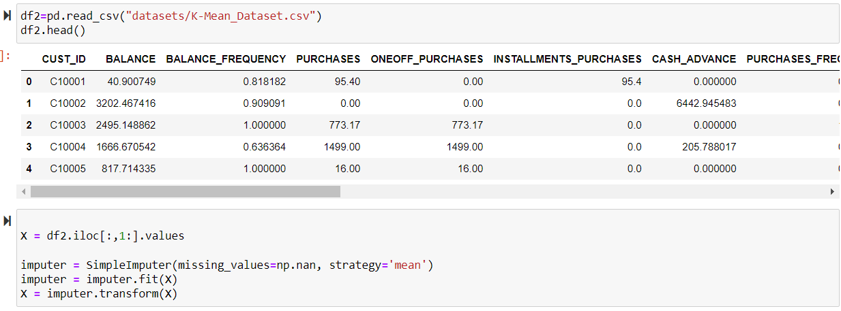

1. Try feature scaling and then apply K-Means on the scaled features. Did that improve the Silhouette score? If yes, can you justify why

